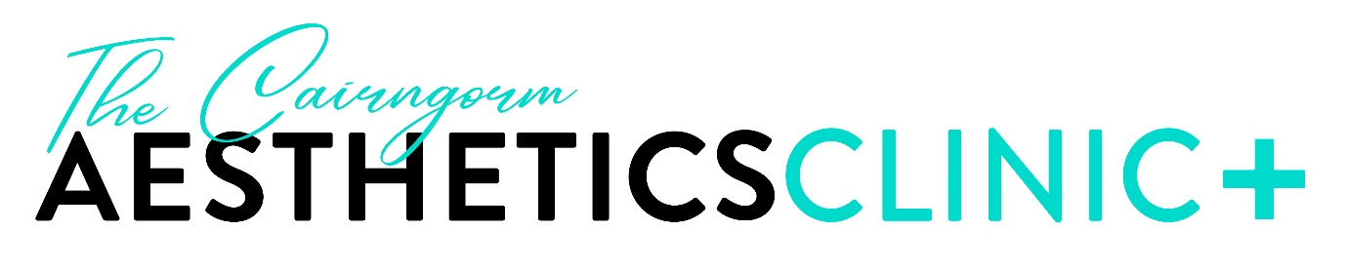

Complaints Policy

The Cairngorm Aesthetics Clinic

Date effective: 01/03/2022
Review Date: 01/10/2025
Version: 1

- Purpose of Policy
The purpose of this policy is to highlight the commitment from The Cairngorm Aesthetics Clinic in handling complaints related to the service. Clients are encouraged to contact the director of the clinic directly if they are dissatisfied with any aspect of their care or aftercare.

- Policy Statement and Aims
The aim of the policy is to respond to a complaint or concern quickly and fairly and by discussing the matter with the client, where appropriate. All complaints are treated seriously. In the majority of cases a complaint or concern will be resolved within 5 days of the complaint being made. The aim is to treat clients with discretion and ensure that confidentiality is maintained during the complaint’s procedure. Th

- Scope
This policy only applies to handling of complaints against The Cairngorm Aesthetics Clinic and the services provided within the company or against the aesthetic practitioner. For the purposes of this policy, a complaint is defined as being expression of dissatisfaction about an act, omission or decision, either verbal or written and whether justified or not which warrants a response.

- Procedure
A complaint can be made by a client or a representative of the client, directly to Lyndsey Robinson of The Cairngorm Aesthetics Clinic. This can be in person, verbally or in writing. The client can contact Lyndsey Robinson via the telephone number or email address for the clinic or by postal address.
A complaint must not be made if is after 6 months the incident took place.
STAGE 1 (Verbal/Informal) complaints:
A complaint or concern can be made directly to Lyndsey Robinson in person, via telephone or in writing.
An acknowledgement to the complaint must be made within 3 working days.
In the majority of cases the complaint will be resolved within 5 business days by Lyndsey Robinson.
STAGE 2 complaints (formal complaints).
If the complainant continues to be dissatisfied with the response of the complaint within the initial 5 days, a written, formal complaint must be logged which will warrant further investigation. Any investigation must be completed and responded to within 30 days.
An acknowledgement of the complaint must be in writing unless in exceptional circumstances where this will be verbal.
There must be an offer to discuss the handling of the complaint.
A response to a complaint must:
• Include an explanation of how the complaint has been considered
• Provide information about who has been involved in the investigation
• Include a meaningful apology where it is due
• Refer to any records, documents or guidelines that have been considered
• Conclude and evidence how a decision was reached
• Tell the complainant what has been done to put things right where appropriate
There may be circumstances where complaints are made face to face. In the event of this, no aggression or violence towards the aesthetic practitioner will be tolerated.
If a complainant behaviour is deemed persistent or unreasonable, this behaviour will be notified to the police.
If the complainant is unhappy with the handling of the complaint or the response to the complaint they can ask the Scottish Public Services Ombudsman (SPSO) to review.
The complainant may also contact Healthcare Improvement Scotland (HIS) at any point during the complaint process or to make a complaint regarding the practitioner or services provided at the clinic. Contact details for HIS are:
Programme Manager
Independent Healthcare Services Team
Healthcare Improvement Scotland
Gyle Square
1 South Gyle Crescent
Edinburgh
EH12 9EB

Tel: 0131 623 4342

Email: his.ihcregulation@nhs.scot

- Responsibilities
The responsibility of implementing this policy is the aesthetic practitioner and business owner Lyndsey Robinson. Acknowledging and investigating complaints will be the responsibility of Lyndsey Robinson

- Compliance
Compliance with this policy is vital and will be carried out by Lyndsey Robinson. Clients are advised to review the complaints procedure if a complaint or concern is raised.

REFERENCES

NHS Highland 2022. Making a complaint. Available at: Complaints Procedure (scot.nhs.uk)
Scottish Government (2022) Complain about an NHS Service. Available at: Complain about an NHS service - mygov.scot
NHS England (2021). NHS England Complaints policy. Available at: NHS England » NHS England Complaints Policy

